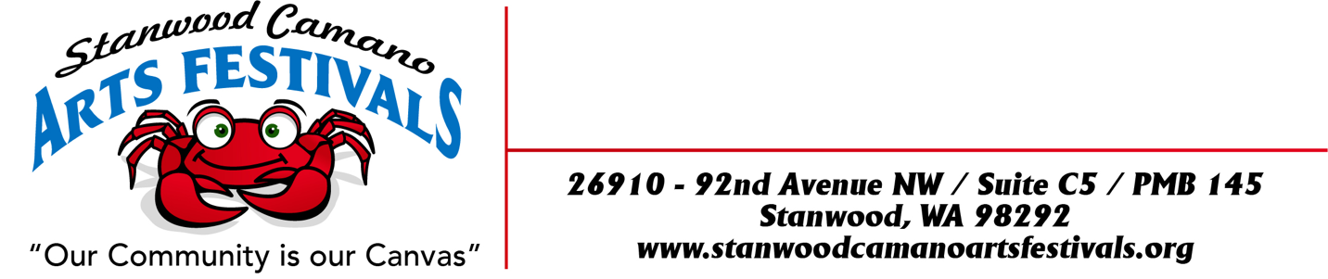

“CAMANO ISLAND SUMMER SOLSTICE ART, BEER and WINE FESTIVAL”
“Our Community Is Our Canvas”

JUNE 23th , 24th & 25th 2023
Rules and Application

LOCATION:
Camano Commons, grassy courtyard behind Camano Island Coffee Roasters and Camano Island Marketplace, 848 N. Sunrise Blvd, Camano Island, WA 98282

FESTIVAL DATES & TIMES:
Friday JUNE 23rd, Saturday 24th & Sunday 25th 10:00am to 5:00pm

SET UP TIMES:
Thursday JUNE 22nd 12:00pm to 7:00pm or Friday June 23rd 7:30am to 9:00am.
Please notify Sally if you plan on setting up on Friday June 23rd
You will be sent an email a couple days before the festival with your check in time.

BOOTH FEES: due by May 31st 2023
Application Fee: $10.00
Single 10 x 10 $100.00
Double 10 x 20 $200.00
Booth locations will be assigned when you check in.
There will be no refunds after June 3rd, and we apologize in advance that there can be no exceptions to this policy.

Double Booths: We have a very limited number of double booth spaces available. If you would like to request one, please send an email to sallyprayscaf@yahoo.com We will do our best to
accommodate your request during our mapping process.
BOOTH GUIDELINES:
This is an outdoor event and your booth must be designed to withstand wind and inclement weather. All tents MUST have weights! Each tent must have at least 50 pounds on each leg. The tents must have all 4 sides on their tents at night. We can get some big winds being on the water, at night especially!
No stakes or anything can be inserted into the grass for weights. All Weights must be above ground due to sprinkler system or blacktop. All booths must be kept open till closing times. Event will be held, regardless of weather.

REQUIREMENT AND RESTRICTIONS:
*Vendors will be staffing their own booth, collecting their own money and paying their own taxes.
*Vendors must obtain all state and local tax permits necessary for operation. Sales tax is 8.7%.
*No onsite food preparation is allowed. Only packaged food to be sold on site such as jams, jellies, sauces, salsa, breads, seasonings and etc. No coffee other than Camano Island Roasters is to be sold. In selling such products will agree to package, sell and sample in according to Washington State, County, City and Federal Regulations and have necessary permits.
*Vendors must provide their own booth pieces complimentary to your craft. Responsible for cleaning up of your own litter from your space.
*No smoking or “hawking” will be allowed in the vicinity of your booth.
*Vendors agree that the management and Stanwood Camano Arts Festivals shall be held blameless and not financially liable for any personal injury to the exhibitor or his/her helper. Management is not liable for any merchandise or property stolen or damaged in any way. The vendor assumes all responsibility.
*All pertinent fire codes, laws, ordinances and regulations pertaining to health, fire prevention and public safety shall be strictly obeyed.
*Vendors shall park at the “Park and Ride” area. No firearms allowed.

DEADLINE TO APPLY: Tuesday May 24th, 2023… Please send check with application fee, booth fee and pictures when applying. If you are not juried in your check will be returned.
Selected Artist Notified May 27th, Booth purchase deadline May 31st, No booth fee refunds after June 3rd , 2023. If you miss the deadline, booth assignments will be “Space Available”. There is a limited amount of booth spaces where we set up for the “Camano Commons Festivals” so get your Application in ASAP.

No stakes or anything can be inserted into the grass for weights. All Weights must be above ground due to sprinkler system or blacktop.

ARTIST APPLICATION ON THE NEXT PAGE

ARTIST APPLICATION FORM

“CAMANO ISLAND SUMMER SOLSTICE ART and WINE FESTIVAL”
JUNE 23^{3d}, 24th & 25th 2023
Rules and Application

BUSINESS NAME:___________________ARTIST NAME: ________________________________

ADDRESS: ______________________________ CITY: ____________ STATE: ____ ZIP: _______

EMAIL: _________________________________ WEBSITE: ______________________________

PHONE: HOME/BUSINESS _________________ CELL: __________________________________

UBI #: (MANDATORY FOR ALL ACCEPTED ENTRANTS) _________________________________

DESCRIPTION OF ART/MEDIUM: ___________________________________________________

PLEASE INCLUDE: 3 PICTURES OF YOUR ART WORK AND 1 PICTURE OF YOUR BOOTH ALONG
WITH A DESCRIPTION OF YOUR WORK THAT YOU ARE PLANNING TO SELL.
BOOTH FEES:
Application Fee: $10.00 $ 10.00 ______
Single 10 x 10 $ 100.00 $ 100.00 ______
Single 10 x 20 $200.00 $ 200.00 ______
TOTAL $ ENCLOSED: ___________________
DATE: __________________ SIGNATURE: ___________________________________________

Make checks out to: Stanwood Camano Arts Festivals
And mail to 26910 – 92nd Ave. NW
Suite C5 - PMB 145
Stanwood, WA 98292
Sally Pray Phone: 360-387-8101 home 425-773-0313 cell EMAIL: sallyprayscaf@yahoo.com

