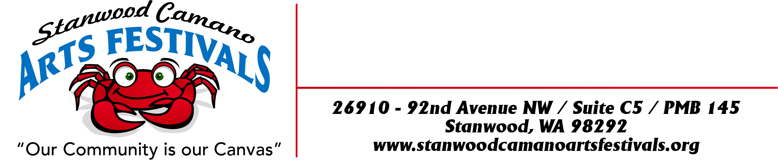

Sponsorship Invitation
“Our Community Is Our Canvas”

16th Annual
“CAMANO ISLAND MOTHERS DAY ARTS FESTIVAL”
MAY 6TH, 7TH 8th 14^{th ,}& 15TH 2022 (Must commit to both weekends to apply)

2nd Year
“CAMANO ISLAND SUMMER SOLSTICE ART and WINE FESTIVAL”
JUNE 10th, 11th & 12TH 2022

We invite you to Partner with us to highlight the Music and the Arts within the Stanwood/Camano community! This area has always been home to many wonderful artists and musicians. Our group of artists realize that the best way for us to showcase our talent is to produce full featured festivals that host a broad range of the Arts in a way that will both entertain and serve community need. Our organization Stanwood Camano Arts Festivals is a state licensed 501c3 which is necessary to bring bigger and better shows to the Stanwood Camano Area while also addressing the needs of our neighbors. Your sponsorship will augment our collective effort to bring more substantially comprehensive shows, encourage tourism and insure your company’s recognition for partnering with other like-minded individuals who are dedicated to doing “good work”. It is important to add that as a sponsor your donations are fully tax deductible.

About us:
Stanwood Camano Arts Festivals is a collaboration of community leaders who produce events throughout the year that promote the arts, enhance commerce and serve the community of Stanwood & Camano Island. We love this area and want to share it.
Our intent is to offer the community an amazing experience while promoting the artists, businesses and individuals who make it possible.

Why sponsor the 2022 Camano Island Mother’s Day Arts Festival and Camano Island Summer Solstice Art & Wine Festival ?
- Your business will be promoted!
  - Promotion/Advertising - As a sponsor you will have the opportunity to promote YOUR company through our advertising campaign! See our Advertising Plan below.
  - Foot Traffic/Increased Sales - Camano Island Mother’s Day Arts Festival and Camano Island Summer Solstice Art & Wine Festival will attract shoppers and patrons to our area’s businesses, restaurants, B&B’s, real estate and more!

- Community Building
  - By sponsoring our festivals throughout the year your investment is one for the community.
  - Your support strengthens our community.

- Tax Deduction
Stanwood Camano Arts Festivals is a 501c3. Donations toward the Camano Island Mother’s Day Arts Festival and Camano Island Summer Solstice Art & Wine Festival and any other Stanwood Camano Arts Festivals events are tax deductible. Stanwood Camano Arts Festivals is aware that the lion’s share of the success for any show is attendance and that means a strong promotional campaign.
How is the Camano Island Mother’s Day Arts Festival and Camano Island Summer Solstice Art & Wine Festival Promoted?
Stanwood Camano Arts Festivals has developed a broad advertising and Public Relations campaign designed to bring visitors to our event including:
- Event Posters
- Stanwood Camano Arts Festivals website (SCAFS.info) created by “Brand Shouter”.
- Discover Stanwood Camano.com
- Newspapers
- AAA Magazine
- Targeted Marketing:
- Camano Island & Stanwood Chambers of Commerce
- Local paper editorials (Stanwood, Arlington Times, Marysville Globe, Crab Cracker)
- Within local businesses and their Social Media
- Our Artists Social Media

Sponsorship Levels

Kryptonite – Title Level Sponsors –$3,000
Being a title sponsor means that:
- YOUR business logo will appear on all of the promotional materials for the Camano Island Mother’s Day Arts Festival and Camano Island Summer Solstice Art & Wine Festival This includes this year’s poster, all ads, banners, website and social media.
- YOUR business name & logo will be on a banner on stage.
- Artist Choice Headliner Sponsor – Gets 1 vote along with the other chosen jurors to pick the Best Booth Award Contest which includes a free booth at next year’s “ Camano Island Mother’s Day Arts Festival and Camano Island Summer Solstice Art & Wine Festival” (2023).
- Use of the Stanwood Camano Art Festival Logo in your advertising
- Logo Placement and company link on the Stanwood Camano Arts Festivals Website
- Public “Thank you” on Music/Entertainment Stage by Marcia Kester our musical Entertainer
- You are SUPPORTING your local Community, Business’s & Artists as we are!

Gold Level Sponsor $1000.00
- YOUR business logo will appear on all of the promotional materials for the Camano Island Mother’s Day Arts Festival and Camano Island Summer Solstice Art & Wine Festival This includes this year’s poster, all ads, banners, website and social media
- Use of the Stanwood Camano Art Festival Logo in your advertising
- Logo Placement and company link on the Stanwood Camano Arts Festivals Website
- Public “Thank you” on Music/Entertainment Stage by Marcia Kester our musical Entertainer
- You are SUPPORTING your local Community, Business’s & Artists as we are!

Silver Level Sponsor - $500
- YOUR business Logo Placement and company link on the Stanwood Camano Arts Festivals Website
- Public “Thank you” on Music/Entertainment Stage by Marcia Kester our musical Entertainer
- You are SUPPORTING your local Community, Business’s & Artists as we are!

Bronze Level Sponsorship - $100
- Logo Placement and company link on the Stanwood Camano Arts Festivals Website
- You are SUPPORTING your local Community, Business’s & Artists as we are!

Complete the enclosed form and mail with check or money order to go to the SCAFS.info Website and DONATE NOW!

Sponsorship Deadline
Sponsorship form, logo art and payment deadline: March 25t^{h} , 2022 by midnight. This allows us to get all information to the printer for placement on posters/brochures, etc. If you need a date extension or have any questions:
Contact Sally Pray at 425-773-0313 Sallyprayscaf@yahoo.com

See next page for Sponsorship Form

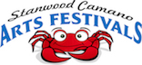
“Our Community Is Our Canvas”

Revised 1/1/22 sp

Sponsorship Form
“Our Community Is Our Canvas”

Sponsorship Level
____ Kryptonite ($5000) Business Name: ___________________________
____ Gold ($1000) Contact Phone: ___________________________
____ Silver ($500) Contact Email: ____________________________
____ Bronze ($100) Business Web-site: ______________________
Business Facebook Page: ________________

Sponsorship Deadline

Sponsorship form, logo art and payment deadline: March 25^{th,} 2022 by midnight.

This allows us to get all information to the printer for placement on posters/brochures, etc. If you need a date extension or have any questions: Contact Sally Pray at 425-773-0313 Sallyprayscaf@yahoo.com

SIGNATURE: _______________________________________________DATE: ____________________________

Donate Online or Mail this completed Email your logo art (with “logo” in the subject)
form with check or money order to: to: SallyPraySCAF@yahoo.com

Stanwood Camano Arts Festivals
Attn: Sponsorship
26910 92nd AVE NW
Suite C5
PMB 145
Stanwood WA 98292

“Our Community Is Our Canvas”

