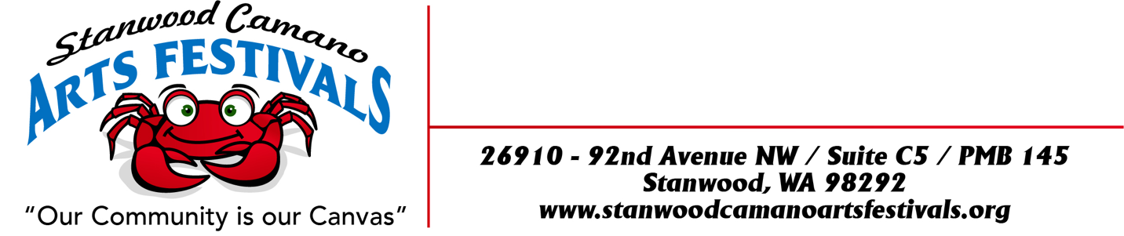
16th Annual
“CAMANO ISLAND MOTHERS DAY ART FESTIVAL”
ON CAMANO IS, WA
Rules and Application

MOTHERS DAY WEEKEND
MAY 6TH, 7^{TH,} 8TH 2022 First Weekend
May 14th & 15th 2022 Second Weekend
Must commit to both weekends to apply
LOCATION:
Camano Commons, grassy courtyard behind Camano Island Coffee Roasters and Camano Island Marketplace, 848 N. Sunrise Blvd, Camano Island, WA 98282

FESTIVAL DATES & TIMES:
Friday May 6th, Saturday 7th & Sunday 8th 10:00am to 5:00pm
Saturday May 14th & Sunday May 15th 10:00am to 5:00pm

SET UP TIMES:
First Weekend:
Thursday May 5th 12:00pm to 7:00pm
Friday May 6th 7:30am to 9:00am
Second Weekend:
Friday May 13th 12:00 to 7:00pm
Saturday May 14th 7:30am to 9:00am
Please notify Sally if you plan on setting up on Friday May 6th or Saturday May 14th.
You will be sent an email a couple days before the festival with your check in time.

BOOTH FEES: due by April 23, 2022. Limited Booth space
Application Fee: $10.00
Single 10 x 10 $130.00
Double 10 x 20 $260.00
Booth locations will be assigned when you check in.
There will be no refunds after April 26, and we apologize in advance that there can be no exceptions to this policy.
Double Booths: We have a very limited number of double booth spaces available. If you would like to request one, please send an email to sallyprayscaf@yahoo.com We will do our best to
accommodate your request during our mapping process.
BOOTH GUIDELINES:
This is an outdoor event and your booth must be designed to withstand wind and inclement weather. Bring weights and sides. Due to COVID restrictions all tents must leave all 3 sides on their tents at all times. We can also get some big winds, at night especially! No stakes or anything can be inserted into the grass for weights. All Weights must be above ground due to sprinkler system or blacktop. All booths must be kept open till closing times. Event will be held, regardless of weather.

REQUIREMENT AND RESTRICTIONS:
*Vendors will be staffing their own booth, collecting their own money and paying their own taxes.
*Vendors must obtain all state and local tax permits necessary for operation. Sales tax is 8.7%.
*No onsite food preparation is allowed. Only packaged food to be sold on site such as jams, jellies, sauces, salsa, breads, seasonings and etc. No coffee other that Camano Island Roasters is to be sold. In selling such products will agree to package, sell and sample in according to Washington State, County, City and Federal Regulations and have necessary permits.
*Vendors must provide their own booth pieces complimentary to your craft. Responsible for cleaning up of your own litter from your space.
*No smoking or “hawking” will be allowed in the vicinity of your booth.
*Vendors agree that the management and Stanwood Camano Arts Festivals shall be held blameless and not financially liable for any personal injury to the exhibitor or his/her helper. Management is not liable for any merchandise or property stolen or damaged in any way. The vendor assumes all responsibility.
*All pertinent fire codes, laws, ordinances and regulations pertaining to health, fire prevention and public safety shall be strictly obeyed.
*Vendors shall park at the “Park and Ride” area. No firearms allowed.

DEADLINE TO APPLY: Monday April 12th, 2022… Please send check with application fee, booth fee and pictures when applying. If you are not juried in your check will be returned.
Selected Artist Notified Friday April 15th, Booth purchase deadline April 23rd, No booth fee refunds after April 26th, 2022. If you miss the deadline, booth assignments will be “Space Available”. There is a limited amount of booth spaces where we set up for the “Camano Commons Festivals” so get your Application in ASAP.

No stakes or anything can be inserted into the grass for weights. All Weights must be above ground due to sprinkler system or blacktop.

PLEASE NOTE: During the COVID-19 pandemic, all events are faced with the possibility of having to cancel up to any time before the show date. If this event is canceled due to COVID-19, an email notification will be sent out to let you know. Booth fees will be refunded in full, or a credit in-full will be provided for our future Festivals. Stanwood Camano Arts Festivals outdoor events will follow 2022 COVID restrictions .

Masks will be required for the duration of the event. No exceptions. We ask vendors to have hand sanitizer in your booth for public use

ARTIST APPLICATION ON THE NEXT PAGE

ARTISTS APPLICATION FORM
CELEBRATING OUR 16th Annual

“CAMANO ISLAND MOTHERS DAY ART FESTIVAL” On CAMANO ISLAND, WA
MAY 6TH, 7^{TH,} 8TH 2022 First Weekend
May 14TH & 15TH 2022 Second Weekend
Must commit to both weekends to apply

BUSINESS NAME:___________________ARTIST NAME: ________________________________

ADDRESS: ______________________________ CITY: ____________ STATE: ____ ZIP: _______

EMAIL: _________________________________ WEBSITE: ______________________________

PHONE: HOME/BUSINESS _________________ CELL: __________________________________

UBI #: (MANDATORY FOR ALL ACCEPTED ENTRANTS) _________________________________

PLEASE INCLUDE: 3 PICTURES OF YOUR ART WORK AND 1 PICTURE OF YOUR BOOTH ALONG
WITH A DESCRIPTION OF YOUR WORK THAT YOU ARE PLANNING TO SELL.
BOOTH FEES:
Send check with application fee and Booth fee when applying. If you are not juried in your check will be returned.

Application Fee: $10.00 $ 10.00 ______
Single 10 x 10 $ 130.00 $130.00 ______
Single 10 x 20 $260.00 $ 260.00 ______
TOTAL $ ENCLOSED: ___________________
DATE: __________________ SIGNATURE: ___________________________________________
Make checks out to: Stanwood Camano Arts Festivals
And mail to 26910 – 92nd Ave. NW
Suite C5 - PMB 145
Stanwood, WA 98292
Sally Prays Phone: 360-387-8101 home 425-773-0313 cell EMAIL: sallyprayscaf@yahoo.com
Rvs 1-7-22 sp

