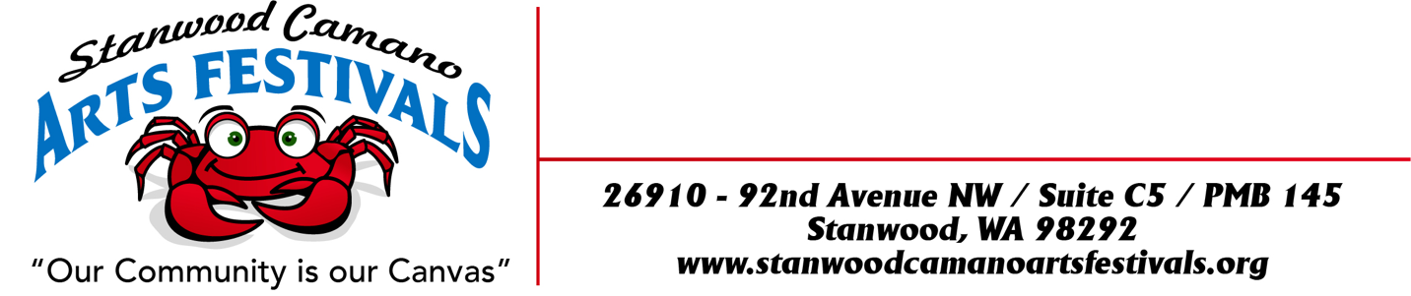

CELEBRATING OUR FIRST #1
“CAMANO ISLAND SUMMER SOLSTICE ART & WINE FESTIVAL”
ON CAMANO IS, WA
Rules and Application

JUNE 25TH, 26^{TH,} & 27TH 2021
LOCATION:
Camano Commons, grassy courtyard behind Camano Island Coffee Roasters and Camano Island Marketplace, 848 N. Sunrise Blvd, Camano Island, WA 98282

TIMES:
Friday JUNE 25th, Saturday 26th & Sunday 27th 10:00am to 5:00pm

SET UP TIME:
Thursday JUNE 24th 2:00pm to 7:00pm or Friday May 7th 7:30am to 9:00am. Artist load in schedule with acceptance email.
.

BOOTH FEES:
Application Fee: $10.00
Single 10 x 10 $100.00
Double 10 x 20 $200.00

BOOTH GUIDELINES:
This is an outdoor event and your booth must be designed to withstand wind and inclement weather. Bring weights and sides. We do get some big winds at night especially! No stakes or anything can be inserted into the grass for weights. All Weights must be above ground due to sprinkler system or blacktop. All booths must be kept open till closing times. Event will be held, regardless of weather.

REQUIREMENT AND RESTRICTIONS ON NEXT PAGE:

REQUIREMENT AND RESTRICTIONS:
*Vendors will be staffing their own booth, collecting their own money and paying their own taxes.
*Vendors must obtain all state and local tax permits necessary for operation. Sales tax is 8.7%.
*No onsite food preparation is allowed. Only packaged food to be sold on site such as jams, jellies, sauces, salsa, breads, seasonings and etc. No coffee other that Camano Island Roasters is to be sold. In selling such products will agree to package, sell and sample in according to Washington State, County, City and Federal Regulations and have necessary permits.
*Vendors must provide their own booth pieces complimentary to your craft. Responsible for cleaning up of your own litter from your space.
*No smoking or “hawking” will be allowed in the vicinity of your booth.
*Vendors agree that the management and Stanwood Camano Arts Festivals shall be held blameless and not financially liable for any personal injury to the exhibitor or his/her helper. Management is not liable for any merchandise or property stolen or damaged in any way. The vendor assumes all responsibility.
*All pertinent fire codes, laws, ordinances and regulations pertaining to health, fire prevention and public safety shall be strictly obeyed.
*Vendors shall park at the “Park and Ride” area. No firearms allowed.
DEADLINE TO APPLY: Monday MAY 17th, 2021…New to the festival? Please send Jury Fee and Pictures.
Selected Artist Notified Friday MAY 21ST, 2021 No booth fee refunds after Monday MAY 24th
If you miss the deadline, booth assignments will be “Space Available”. There is a limited amount of booth spaces where we set up for the “Camano Commons Festivals” so get your Application in ASAP.

No stakes or anything can be inserted into the grass for weights. All Weights must be above ground due to sprinkler system or blacktop.

PLEASE NOTE: During the COVID-19 pandemic, all events are faced with the possibility of having to cancel up to any time before the show date. If this event is canceled due to COVID-19, an email notification will be sent out to let you know. Booth fees will be refunded in full, or a credit in-full will be provided for our future Festivals. Stanwood Camano Arts Festivals outdoor events are now planned to resume for 2021 as COVID restrictions are lifted.

Masks will be required for the duration of the event. No exceptions. We ask vendors to have hand sanitizer in your booth for public use

ARTIST APPLICATION ON THE NEXT PAGE

ARTIST APPLICATION FORM

FIRST #1
“CAMANO ISLAND SUMMER SOLSTICE ART and WINE FESTIVAL”
JUNE 25th, 26th & 27TH 2021

BUSINESS NAME:___________________ARTIST NAME: ________________________________

ADDRESS: ______________________________ CITY: ____________ STATE: ____ ZIP: _______

EMAIL: _________________________________ WEBSITE: ______________________________

PHONE: HOME/BUSINESS _________________ CELL: __________________________________

UBI #: (MANDATORY FOR ALL ACCEPTED ENTRANTS) _________________________________

DESCRIPTION OF ART/MEDIUM: ___________________________________________________

PLEASE INCLUDE: 3 PICTURES OF YOUR ART WORK AND 1 PICTURE OF YOUR BOOTH ALONG
WITH A DESCRIPTION OF YOUR WORK THAT YOU ARE PLANNING TO SELL.
BOOTH FEES:
Application Fee: $10.00 $ 10.00 ______
Single 10 x 10 $ 100.00 $ 100.00 ______
Single 10 x 20 $200.00 $ 200.00 ______
TOTAL $ ENCLOSED: ___________________
DATE: __________________ SIGNATURE: ___________________________________________

Make checks out to: Stanwood Camano Arts Festivals
And mail to 26910 – 92nd Ave. NW
Suite C5 - PMB 145
Stanwood, WA 98292
Sally Pray Phone: 360-387-8101 home 425-773-0313 cell EMAIL: sallyprayscaf@yahoo.com

